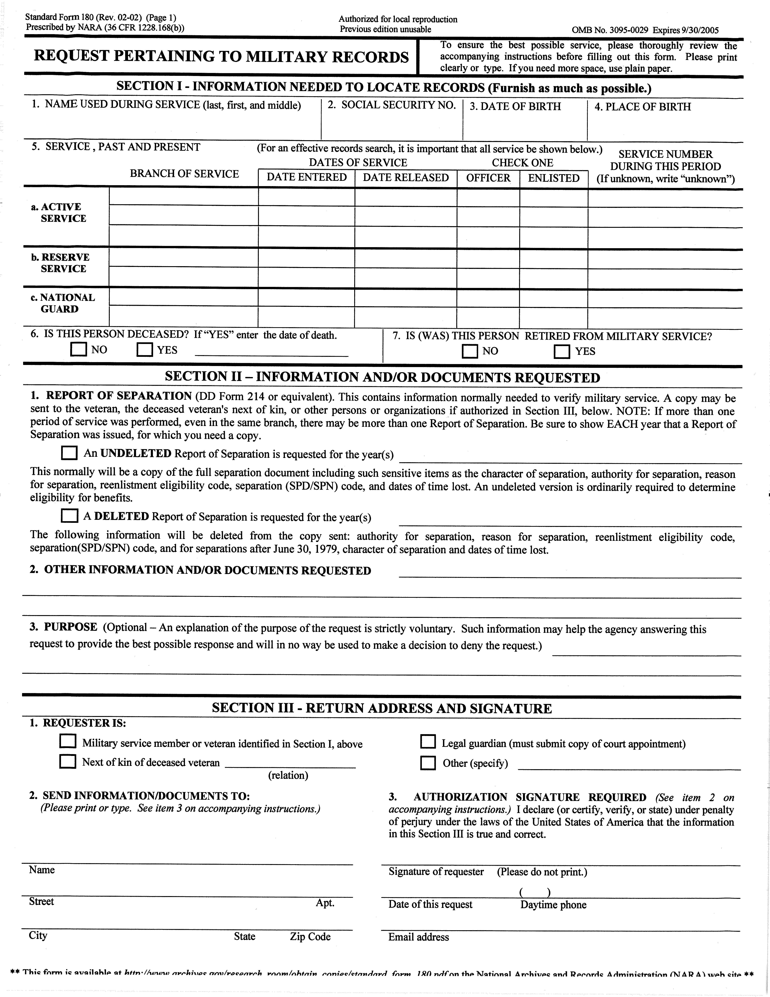
Any and all records generated from 06/30/1927 to present pertaining to Mary Hoag SSN: 367-22-8319, DOB: 06/30/1927.
Order No. 01-10544 - 005 -- Contact: Vicki Lintemuth
Mary Hoag
367-22-8319
06/30/1927
√
A.C.R.C. Requisition Copy Service
447 North Canal Road
Lansing MI 48917

